Reporting for KFX
Kardex INTERNAL ONLY
v4.6.0

Contents
Section 1 What Is Reporting? 3
Section 2 Why Does Kardex or Customers Want Reporting? 3
Section 3 Caveats 3
Section 4 Installing Reporting Database 5
4.1 Verify SQL Server Agent Service Running 5
4.2 Database Deployment Scripts 5
Section 5 Power BI Integration 7
5.1 Prerequisites and Installing Power BI Desktop 7
5.2 Connect Power BI to SQL Server Instance 8
Section 6 Publish PowerBI Reports 14
Section 7 Reporting Architecture Notes 23
7.1 Reporting Database Overview 23
7.2 ProcessData Stored Procedure Breakdown 24
7.3 ProcessDynamicData Stored Procedure Breakdown 26
Section 8 Testing Power BI 28

What Is Reporting?
Reporting requires a different data structure than the standard FulfillX databases. For example, the FulfillX databases know how much inventory is in the system right now. However, those data tables cannot be used to determine how much inventory was in the system two weeks ago; that requires a different type of database that takes “snapshots” of data to track changes over time.
Reporting for FulfillX is accomplished by way of a separate database named KFX_REPORTING and related SQL Agent jobs that run on an hourly basis to synchronize, transform, and optimize FulfillX data for historical reporting.

Why Does Kardex or Customers Want Reporting?
Reporting is an important feature for both Kardex and for our customers. For Kardex, providing a reporting database is a value-add for our customers who want to know about system throughput, performance metrics, and inventory activity to name a few. Having a separate reporting database not only makes efficient, useful reporting possible, but it ensures the load on the main databases for FulfillX are not doing reporting-type work and adversely impacting the system.
Customers of course benefit from having a database that can help provide answers about various metrics across time that are not otherwise available.

Caveats
Important: Only trusted users should have access to the Power BI pbix file. Any changes to the connection, model, or measures in the pbix can break reports. It is recommended that Power BI reports be published, and access managed by trusted users (see Publish PowerBI Reports).
Important: the KFX_REPORTING database resides on the same SQL Server that hosts the FulfillX databases. This means excessive use of reporting could potentially have an adverse effect on overall system performance for FulfillX.
To minimize impact, we recommend the following best practices for running custom reports against the FulfillX production database:
- Run Reports During Off-Hours
  - Execute queries during times of minimal AutoStore activity or when operations are halted.
  - If reports have been published to Microsoft workspace, ensure the database gateway doesn’t refresh more frequently than needed (see Publish PowerBI Reports).
- Optimize Query Design (if custom reporting queries created by customer)
  - Specify only the columns required for the report, avoiding the use of wildcards (SELECT *).
  - Restrict the number of rows returned to meet the report’s needs while minimizing system load.
- Avoid Transactions in Reporting Queries (if custom reporting queries created by customer)
  - Avoid using transactions in T-SQL for reporting purposes. While transactions may ensure data consistency in complex scenarios (e.g., data consistency in a complex multi-user scenario), they can negatively affect database performance.
For more details on the reporting architecture and its implications, refer to the PowerBI Architecture Notes section of this document.

Installing Reporting Database
This document shows the step-by-step process for creating the FullfillX reporting database.
The reporting database created is a database named KFX_REPORTING.
The document assumes that Power BI integration will be utilizing a custom read-only user account provided for reporting purposes (refer to Section 2: Caveats).
Note: links to header sections can be navigated with Ctrl+Click, and section headers can be Ctrl+Click to jump back to top of document.

Verify SQL Server Agent Service Running
  - Ensure that the SQL Server Agent Service is running. If the service is not running, follow the steps below to start it otherwise the sync will not work.
    - Open SQL Server Management Studio.
    - In Object Explorer, locate SQL Server Agent.
    - Right-click on SQL Server Agent and select Start.
    - If start mode is not set to Automatic, be sure to set start mode to Automatic.
  - This setup ensures that the sql agent service is available for sql agent jobs that synchronize data into the reporting database
    - 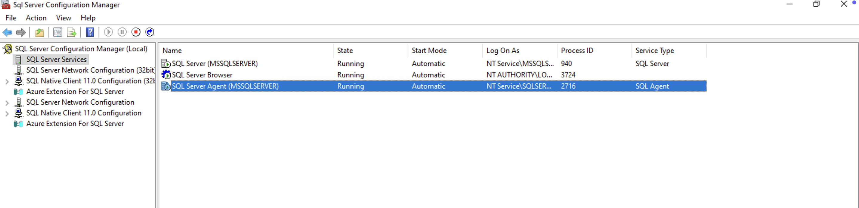

Database Deployment Scripts

Create Reporting Database and Sync Jobs
All scripts referenced in steps below can be found in Sharepoint under this folder.
- Open the create-reporting-database-v4.6.0.sql file in SQL Server Management Studio (SSMS) and execute it to create the database structure.
  - This script will create the necessary tables and stored procedures in the database.
  - Validate script worked by refreshing the Databases node of the tree in SSMS.
  - You should see the KFX_REPORTING database like this:
  - 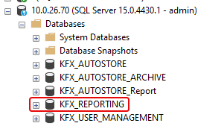
- Open the create-reporting-sync-job-v4.6.0.sql file in SSMS.
  - Update @LoginName if needed.
  - Execute script to create an automated job.
  - This job will run every 1 hour to retrieve incremental data from the source and transfer it to the target database.
  - Validate job exists by refreshing SQL Server Agent node in SSMS tree and finding reporting-sync-job under Jobs node of tree (see screenshot below).
- Open the create-reporting-snapshot-sync-job-v4.6.0.sql file in SSMS.
  - Update @LoginName if needed.
  - Execute script to create an automated job.
  - This job will run every 1 hour to retrieve incremental data from the source and transfer it to the target database while translating JSON data into target database tables for faster performance.
  - Validate job exists by refreshing SQL Server Agent node in SSMS tree and finding reporting-sync-job under Jobs node of tree (see screenshot below).
- Open the create-reporting-cleanup-job-v4.6.0.sql file in SSMS.
  - Update @LoginName if needed.
  - Execute script to create an automated job.
  - This job will run every 12 hours to retrieve incremental data from the source and transfer it to the target database.
  - Validate job exists by refreshing SQL Server Agent node in SSMS tree and finding reporting-sync-job under Jobs node of tree (see screenshot below).
- Verify job schedules
  - Find the three sync jobs under SQL Server Agent à Jobs as shown here:
  - 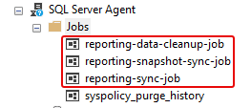
  - Right-click each job, click Properties, and then click Schedules. You can validate the schedule by looking at Description as shown below:
  - 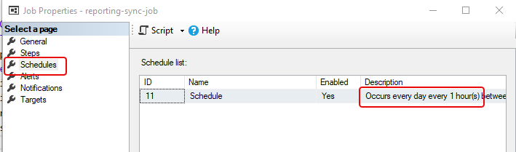
  - reporting-data-cleanup-job should run every 12 hours.
  - reporting-snapshot-sync-job should run every 1 hour.
  - reporting-sync-job should run every 1 hour.

Power BI Integration
Microsoft Power BI is a robust, industry-standard tool for visualizing operational data.
The current implementation of Power BI for FulfillX uses an on-premises installation of the Power BI client to access SQL Server data via a read-only user role designated for reporting purposes. Clients may choose to publish reports into a Power BI workspace to share them with other users.
Licensing, deployment, and management of report access and permissions are the client’s responsibility. This document includes steps in the Publish Power BI Reports section to assist with the process.

Prerequisites and Installing Power BI Desktop
To set up the Power BI database and scheduling job, ensure the following prerequisites are met:
- SQL Server: Version 16.0 or later.
- Power BI Desktop: Power BI Desktop - Free download and install on Windows | Microsoft Store
- Power BI Pro License: Required to publish the reports for non-trusted users to view reports (see Publish PowerBI Reports).
- Database Connectivity: Ensure connectivity and accessibility to the source SQL Server database, especially if it is hosted on a different server.

Assumptions
The process assumes:
- A running SQL Server instance is available.
- The user has appropriate privileges to execute database creation and DDL (Data Definition Language) scripts.

Connect Power BI to SQL Server Instance
Download PowerBI reporting file Kardex-v4.6.0.pbix in v4.6.0 > Release > Assets folder on Sharepoint.
This file includes a Daily KPI report that uses the KFX_REPORTING database to show historical data for 13 metrics by date range.
Follow these steps to install the Power BI application and connect it to the reporting SQL Server database:
- Download and install the Power BI application from the following link: https://www.microsoft.com/en-us/download/details.aspx?id=58494
- Open the Power BI application after installation
  - 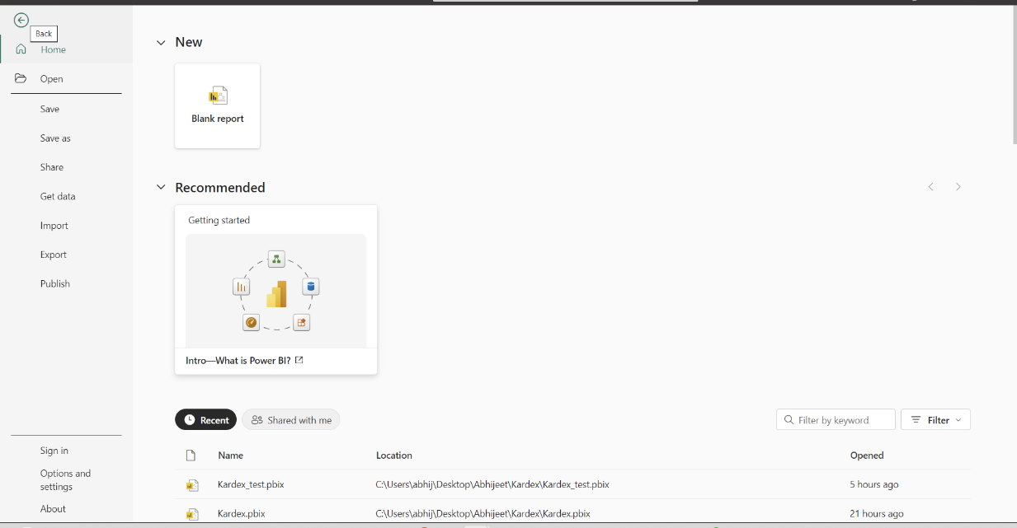
- Navigate to File → Options and Settings → Data source settings.
  - 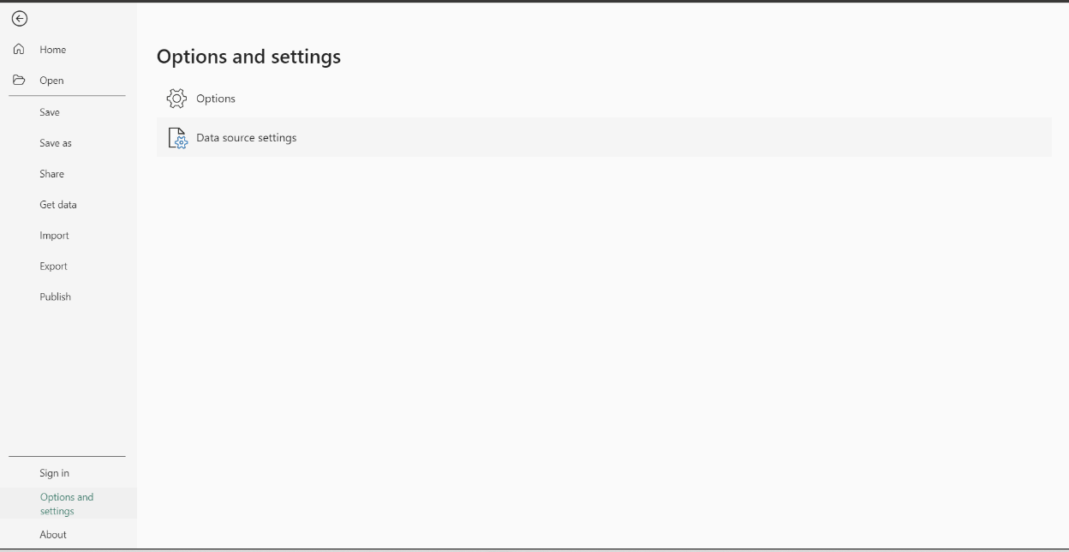
- Click Change Source. Provide the Server Name and Database Name for the SQL Server instance you wish to connect to.
  - 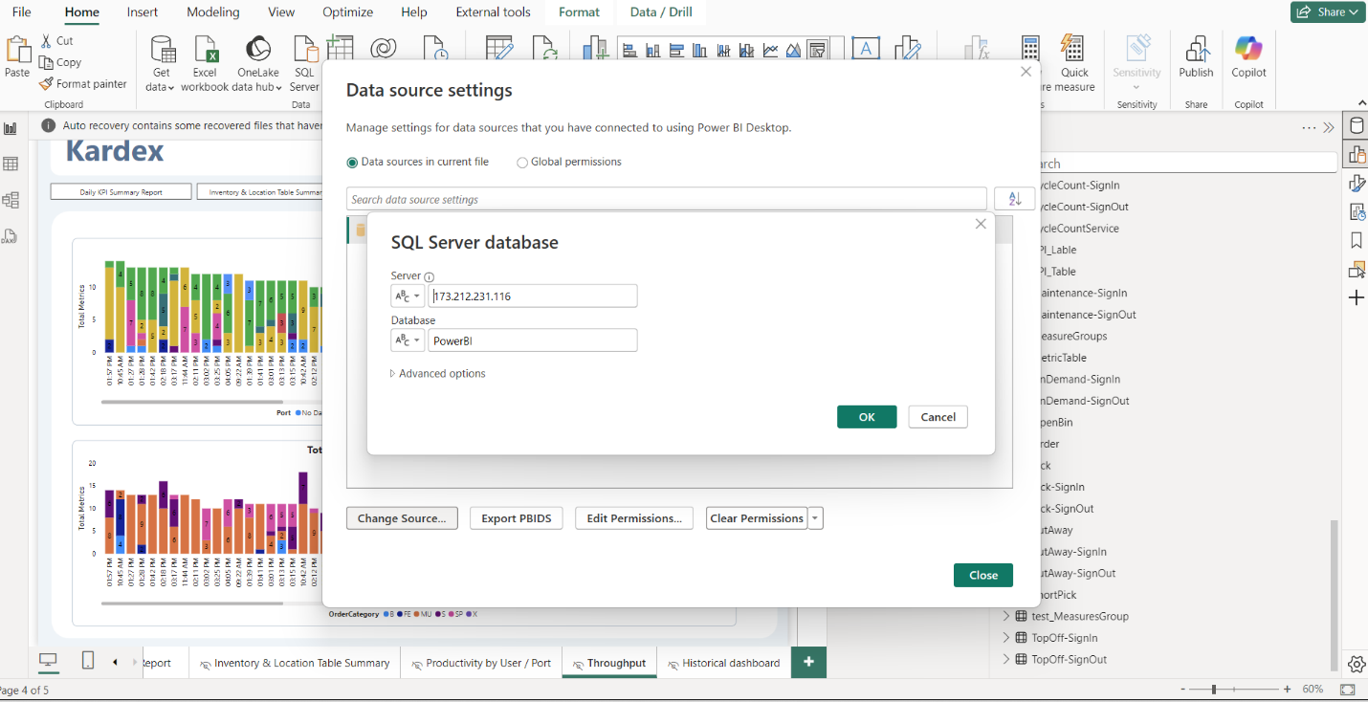
- In the Data source settings window, click Edit Permissions.
  - 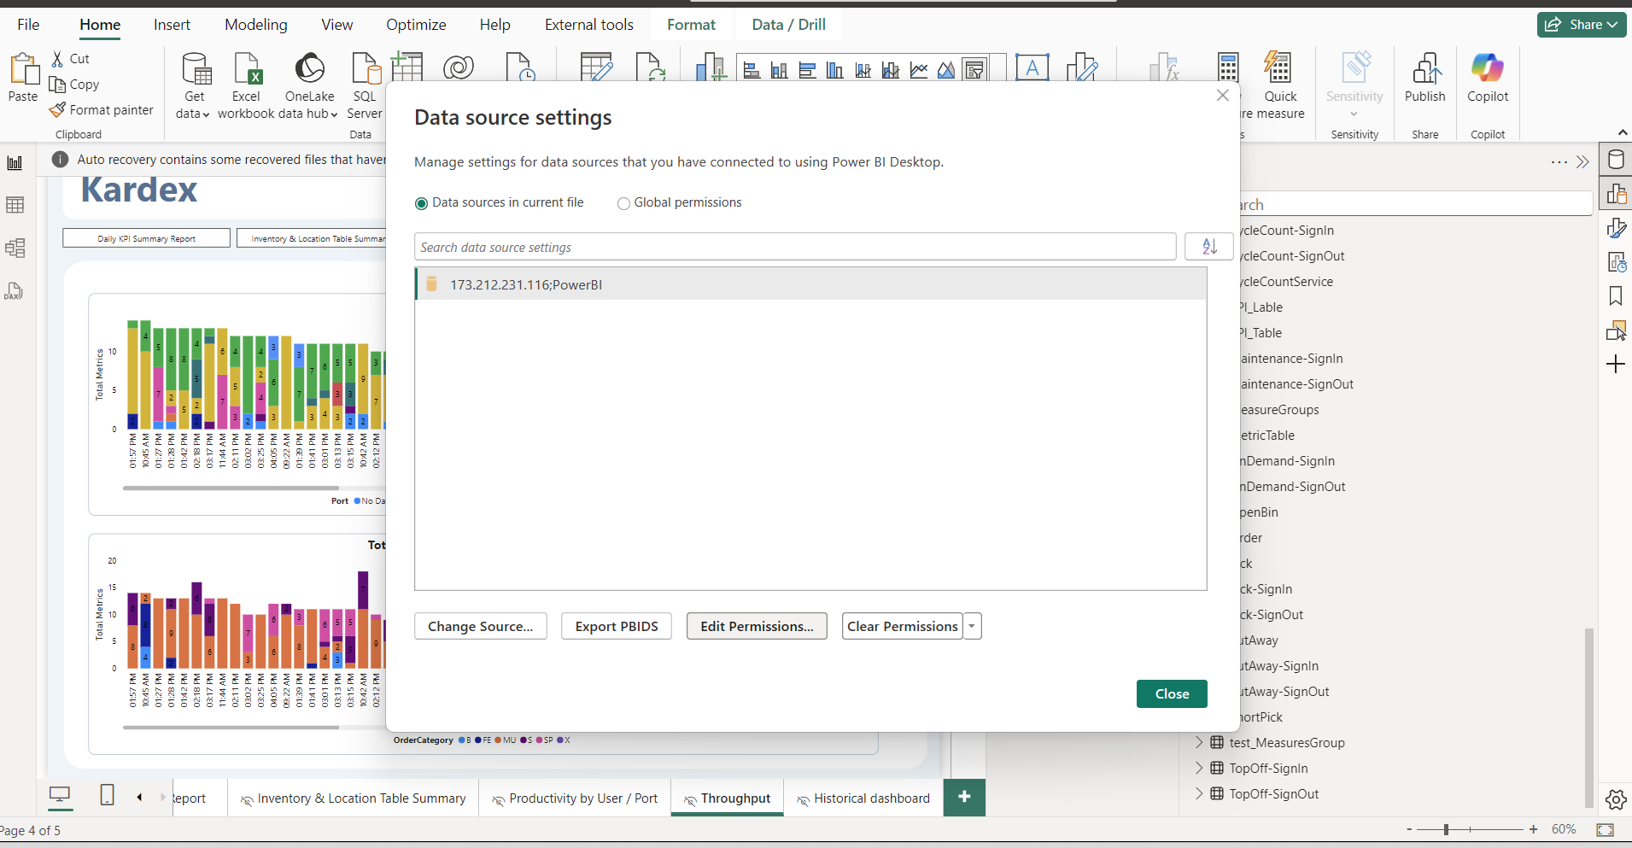

- Click Edit under credentials.
  - 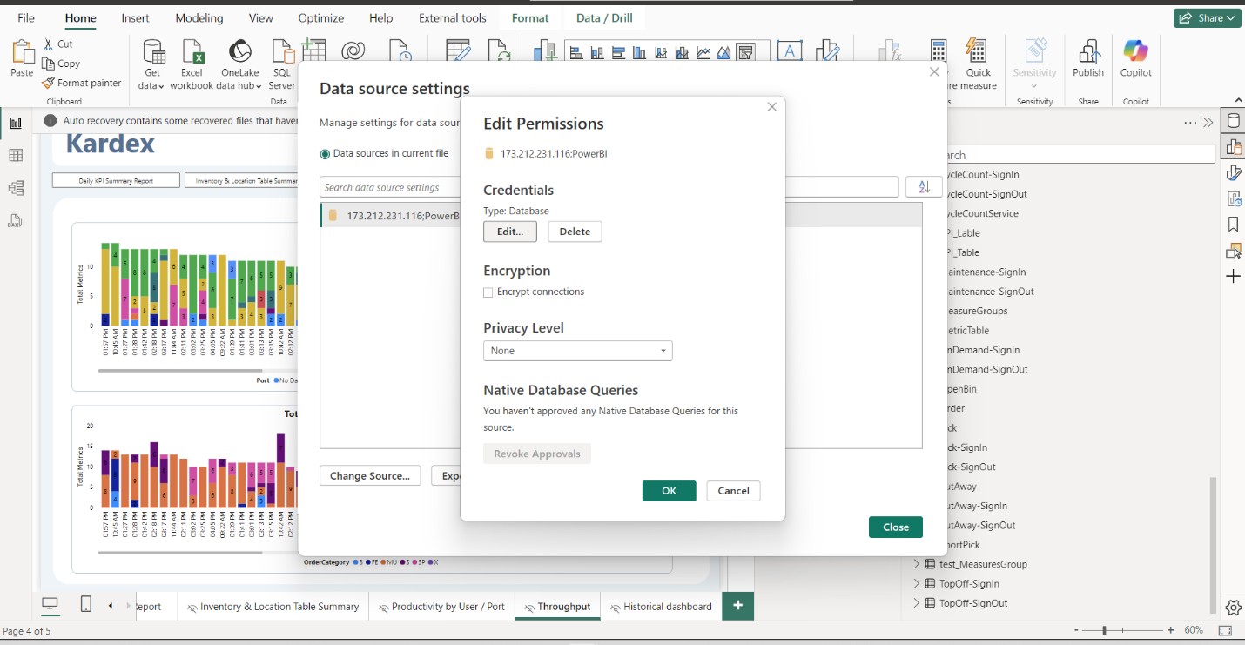
- Click Database on the right and then enter the SQL Server username and password in the dialog box (see screenshot below).
  - 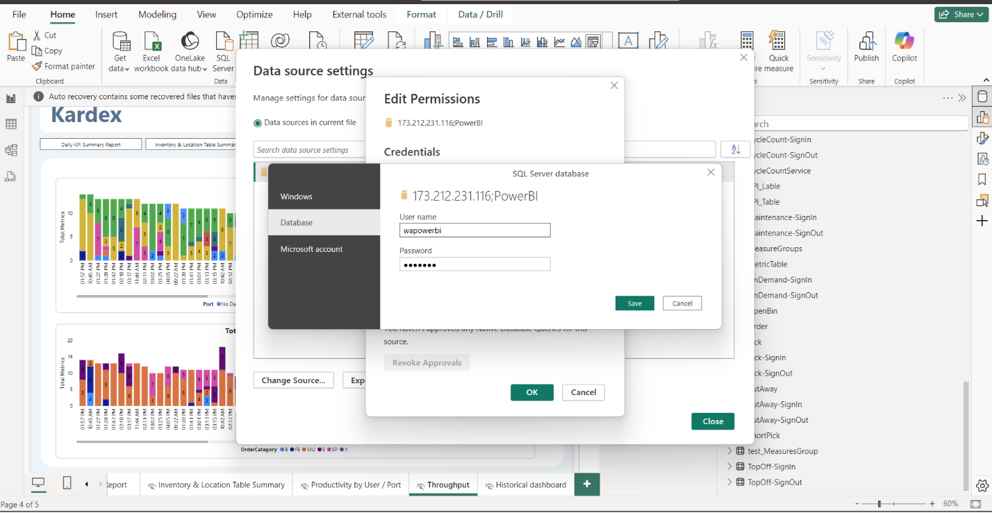
- Once you click Ok back to the Power BI page, you will need to Appy Changes
- 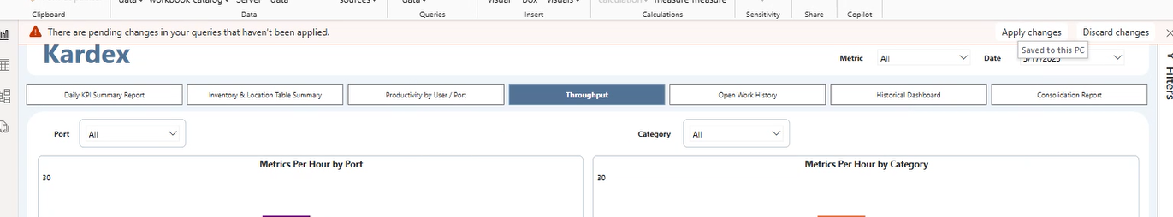
- It will take several minutes for Power BI to pull data from the server.
  - Note: Power BI pulls data and scores it within itself, so each time it pulls data or refreshes it can be slow.
  - 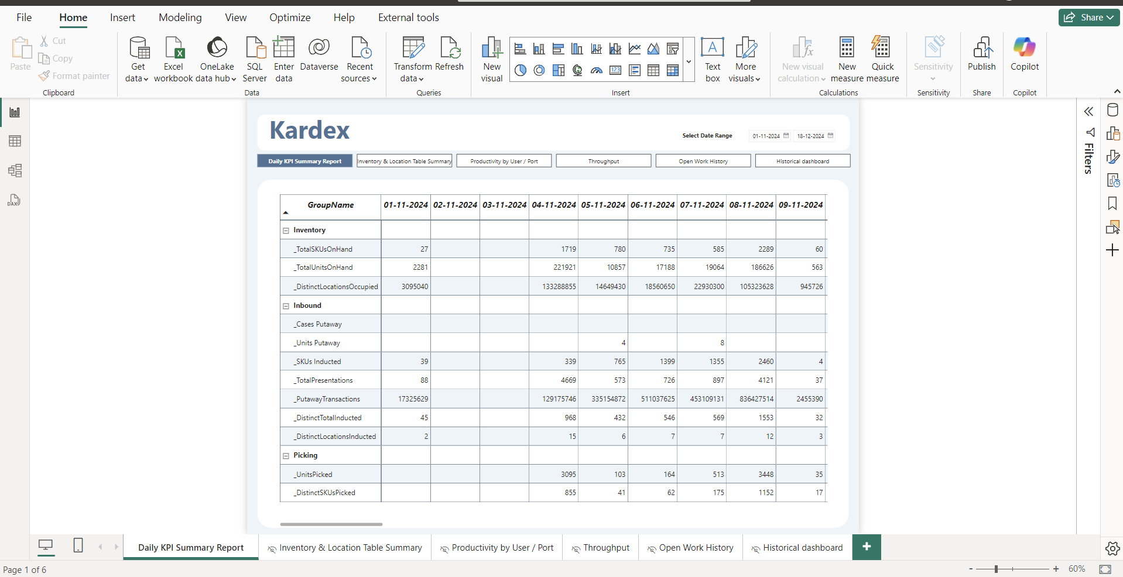

Publish PowerBI Reports
Publishing Kardex reports is ideally managed by an individual responsible for overseeing the reporting needs of the operation. While Kardex provides a reporting database and example reports, publishing Power BI reports to a Microsoft workspace is the client's responsibility:
- Publishing reports to a Power BI workspace.
- Maintaining user permissions and access to the reports.
This section is intended to assist clients who wish to publish reports for broader accessibility, as opposed to simply opening the Kardex.pbix file for local viewing.

- Publish: Open the Kardex.pbix file in the Power BI application. Click the Publish button in the toolbar.
  - 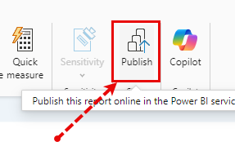
- Choose the workspace: In the popup screen, choose the workspace where you want to publish the report.
  - 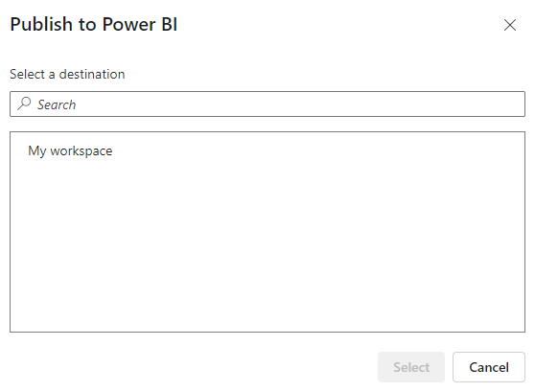
  - The screenshots in this document assume publishing to the default My Workspace.
  - For more information on Power BI workspaces, refer to: How content is organized in workspaces - Power BI | Microsoft Learn
  - You will see a dialog box showing the publishing progress:
  - 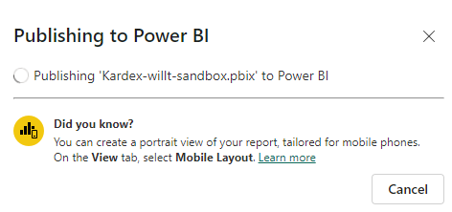
- Create New Workspace (optional): if you want to publish to a different workspace, you can create a new workspace in your Power BI account.
  - Power BI account: https://app.powerbi.com/
  - 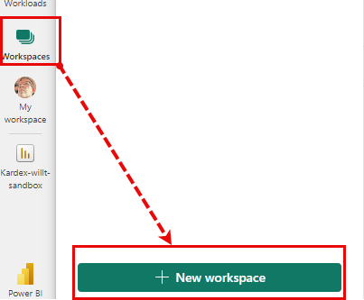
  - You can give workspace a meaningful name, description, and even an icon/graphic if you like:
    - 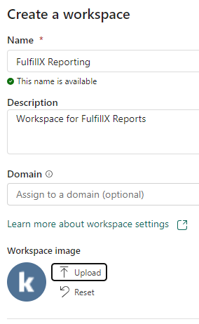
    - Note that creating workspaces and sharing reports requires Power BI licensing, which is not provided by Kardex. For example, you might see a popup like this:
    - 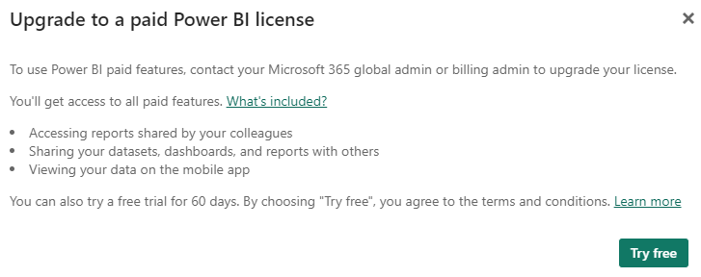
    - Also, your Power BI tenant administrator may have to give you permissions to create new workspaces.
    - To learn more about tenant administration: Power BI implementation planning: Tenant administration - Power BI | Microsoft Learn
- Open Workspace: once the report has been published to a workspace, there is a link in the confirmation to go to that workspace:
  - 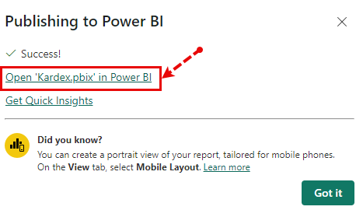
  - Once in the workspace click the name of the publish report.
  - You can then view your reports
  - 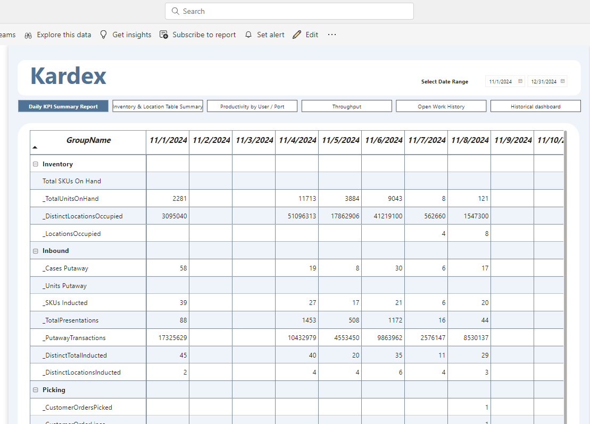
- Share Report: to share the report you can click the Share button in the ribbon above the report.
  - 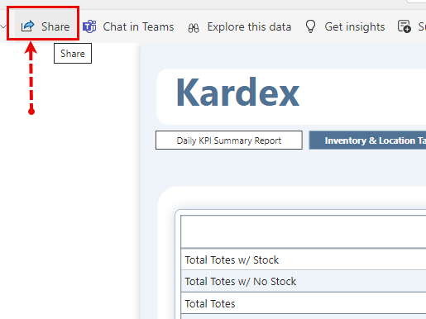
  - You will see a popup dialog like this:
    - 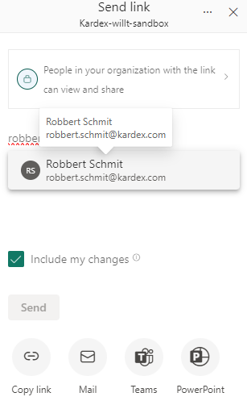
    - Enter the email addresses of the users you want to share with.
    - Set permissions (e.g., allow users to share the report or export data).
    - Click Send.
  - Embed or Generate Link (Optional):
    - To embed the report in a website or app, click File → Embed.
    - Generate a link to share directly with users.
    - 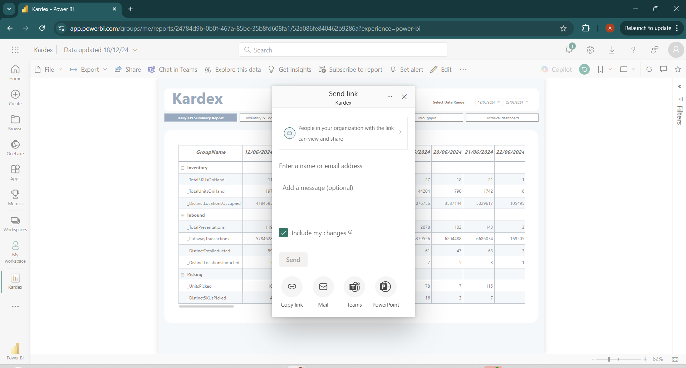
- Enable Auto Refresh and Manage Datasets
  - Set Data Refresh:
    - Configure refresh settings for each dataset in Power BI Service.
    - If any dataset requires on-premises access, set up a Data Gateway.
    - Click on settings and enable Gateway (This must be installed and configured to enable the auto refresh)
    - 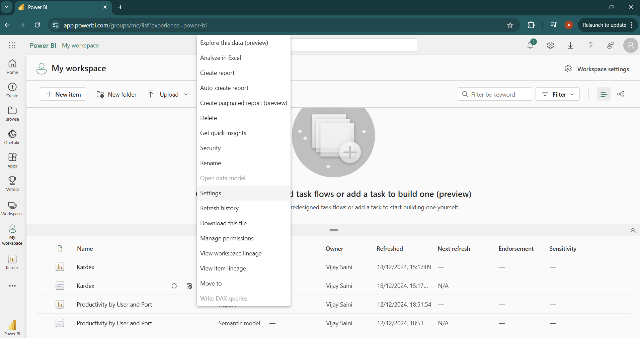
  - Install the Gateway
    - 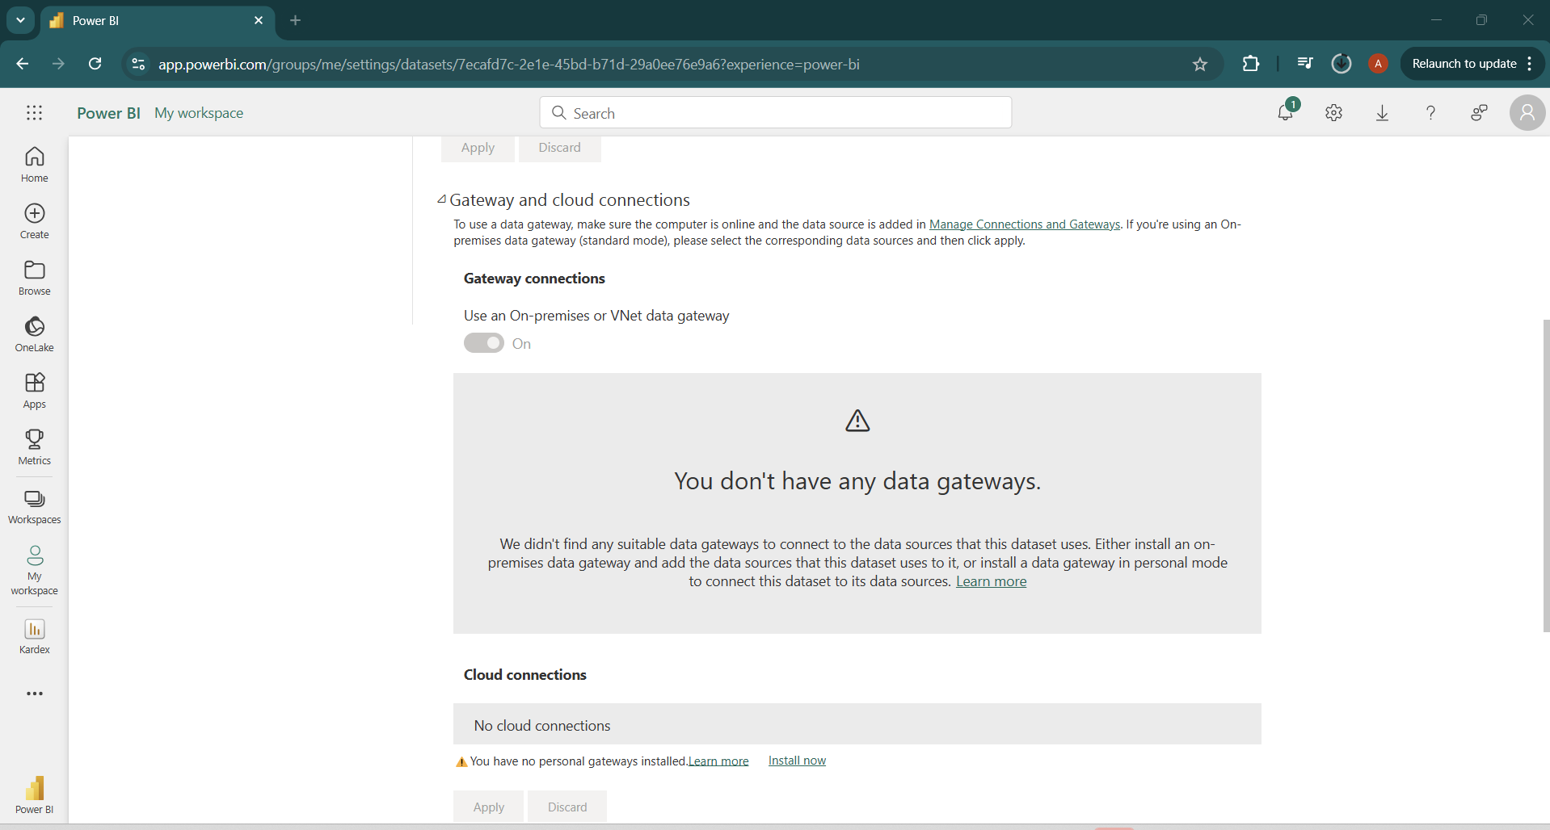
    - 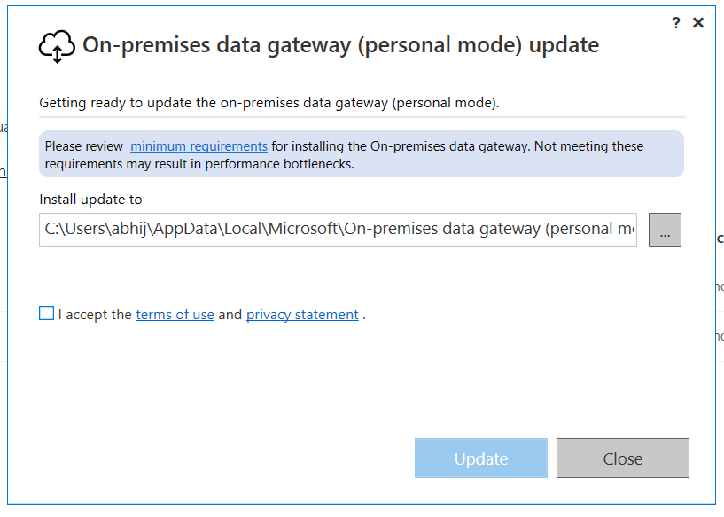
  - Use the Gateways for different data sources.
    - 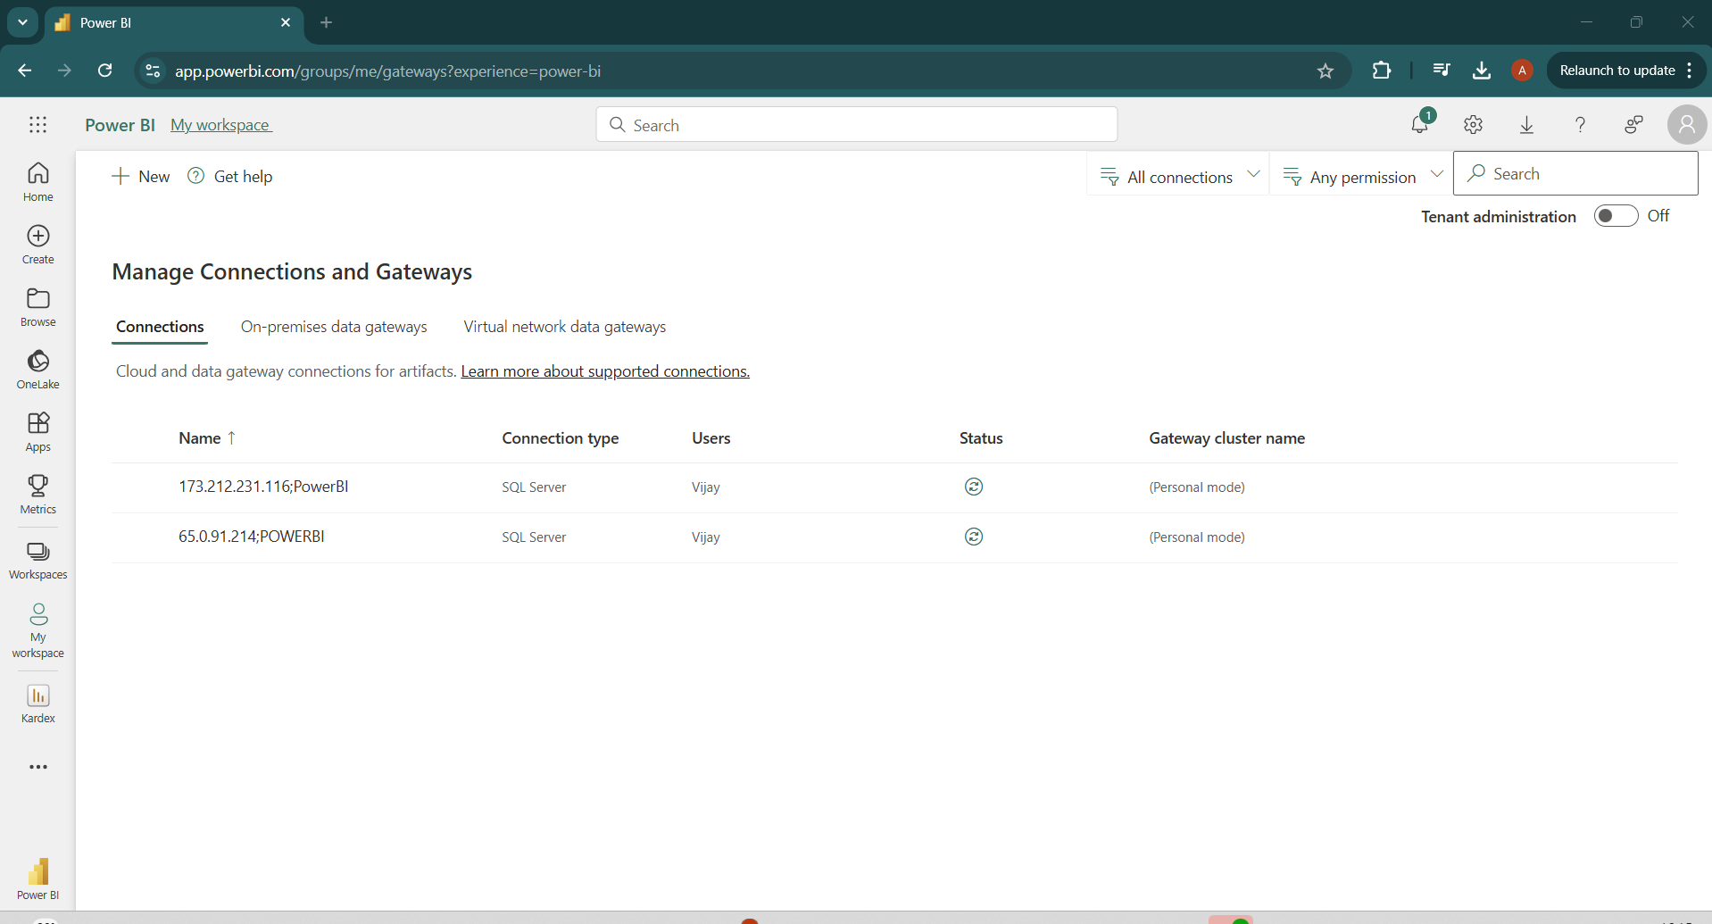
    - This will retrieve data from the server at scheduled intervals and automatically refresh the reports.

Reporting Architecture Notes

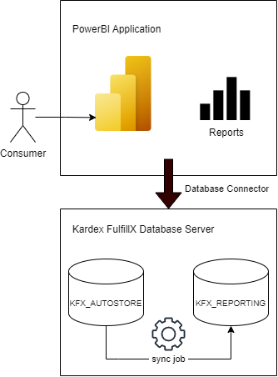

Reporting Database Overview
The overall process involves a scheduled jobs that executes SQL scripts to synchronize data from the production database (KFX_AUTOSTORE) to the reporting database (KFX_REPORTING).
This ensures the reporting database remains up to date with the latest operational data while keeping reporting activities separate from the production database to minimize performance impacts.
Power BI can be installed on any machine with network access to the Kardex FulfillX Database Server, allowing it to display report data effectively.
The KFX_REPORTING database includes a metadata table named DataSyncDetail, which contains detailed information about each synchronization job run. This table helps monitor and validate the data sync process between the production database (KFX_AUTOSTORE) and the reporting database (KFX_REPORTING).
Note: the KFX_REPORTING database can be used to query for reporting data separately from Power BI. Power BI has a few sample reports, but the reporting database can be used to expose and visualize data in any tool desired.

Reporting Database Sync Jobs
reporting-sync-job: executes ProcessData then executes ProcessDataCompletion stored procedures (details below).
reporting-snapshot-sync-job: executes ProcessDynamicData, then executes ProcessDynamicDataCompletion stored procedures (details below).
reporting-sync-job: executes DeleteDynamicData stored procedure, then executes DeleteDynamicDataCompletion.

ProcessData Stored Procedure Breakdown
The ProcessData stored procedure is responsible for creating and populating various tables that store KPI-related data. It calculates metrics such as average handling time, bin presentations completed, bins per hour, lines completed, orders completed, units completed, and total logged time, grouped by either port or user. It also creates tables for hourly metrics and aggregates data from other tables.

Here is the list of stored procedures executed under the ProcessData stored procedure:

Stored Procedure Name | Description | Affected Table(s)
ProcessData_ContainerTemplateCompartments_LIVE | Synchronizes data from the ContainerTemplateCompartments table in the KFX_AUTOSTORE database to the KFX_REPORTING database. Handles batch inserts and updates. | ContainerTemplateCompartments  DataSyncDetail
ProcessData_ContainerCompartmentBarcodes_LIVE | Synchronizes data from the ContainerCompartmentBarcodes table in the KFX_AUTOSTORE database to the KFX_REPORTING database. Handles batch inserts and updates. | ContainerCompartmentBarcodes  DataSyncDetail
ProcessData_TaskCategories_LIVE | Synchronizes data from the TaskCategories table in the source database to the target database. Handles batch inserts and updates. | TaskCategories  DataSyncDetail
ProcessData_ReportedMetrics_LIVE | Processes data from the ReportedMetrics table, inserts it into the Report_Data table, and further processes specific data descriptions into corresponding tables. | Report_Data  BinPresented  CloseBin  CloseBin-InventoryRecord  CycleCountService  CycleCount-SignIn]  CycleCount-SignOut  Maintenance-SignIn  Maintenance-SignOut  OnDemand-SignIn  OnDemand-SignOut  OpenBin  Order  Pick  Pick-SignIn  Pick-SignOut  PutAway  PutAway-SignIn  PutAway-SignOut  ShortPick  TopOff-SignIn  TopOff-SignOut
CreateKPITables | Creates various KPI-related tables by aggregating data from existing tables to provide metrics such as handling time, bin presentations, lines completed, orders completed, and units completed. | Affected Tables:  AverageHandlingTimePerPort_Table  AverageHandlingTimePerUser_Table  BinPresentationsCompletedPerPort_Table  BinPresentationsCompletedPerUser_Table  BinsPerHourPerPort_Table  BinsPerHourPerUser_Table  LinesCompletedPerPort_Table  LinesCompletedPerUser_Table  LinesperHourPerPort_Table  LinesperHourPerUser_Table  MachineWaitTimePerPort_Table  MachineWaitTimePerUser_Table  OrdersCompletedPerPort_Table  OrdersCompletedPerUser_Table  OrdersPerHourPerPort_Table  OrdersPerHourPerUser_Table  UnitsCompletedPerPort_Table  UnitsCompletedPerUser_Table  UnitsPerHourPerPort_Table  UnitsPerHourPerUser_Table  TotalLoggedTimePerPort_Table  TotalLoggedTimePerUser_Table  DefragDetailByUomCompartmentSize_Table

ProcessDynamicData Stored Procedure Breakdown
The ProcessDynamicData stored procedure is responsible for orchestrating the synchronization and snapshotting of data from the KFX_AUTOSTORE database into corresponding snapshot tables in the KFX_REPORTING database. It ensures data consistency by processing batches and updating the DataSyncDetail table to track the synchronization status.

Here is the list of stored procedures executed under the ProcessDynamicData stored procedure:

Snapshot Tables
Snapshot tables have a stored procedure that updates affected tables as follows:

Stored Procedure Name | Description | Affected Table
ProcessData_Inventory_LIVE | creates a snapshot of inventory data | Inventory_Snapshot
ProcessData_Containers_LIVE | creates a snapshot of container data | Containers_Snapshot
ProcessData_CompartmentSizes_LIVE | creates a snapshot of compartment size data | CompartmentSizes_Snapshot
ProcessData_ContainerTemplates_LIVE | creates a snapshot of container template data | ContainerTemplates_Snapshot
ProcessData_Ports_LIVE | creates a snapshot of port data | Ports_Snapshot
ProcessData_Locations_LIVE | creates a snapshot of location data | Locations_Snapshot
ProcessData_ReasonCodes_LIVE | creates a snapshot of reason codes | ReasonCodes_Snapshot
ProcessData_PutAwayContainers_LIVE | creates a snapshot of put-away container data | PutAwayContainers_Snapshot
ProcessData_PutAwayContainerLineItems_LIVE | creates a snapshot of put-away container line items | PutAwayContainerLineItems_Snapshot
ProcessData_InventoryTasks_PutAway_LIVE | creates a snapshot of inventory tasks related to put-away operations | InventoryTasks_PutAway_Snapshot
ProcessData_InventoryTasks_LIVE | creates a snapshot of general inventory tasks | InventoryTasks_Snapshot
ProcessData_FulfillmentOrders_LIVE | creates a snapshot of fulfillment orders | FulfillmentOrders_Snapshot
ProcessData_FulfillmentOrderLines_LIVE | creates a snapshot of fulfillment order lines | FulfillmentOrderLines_Snapshot
ProcessData_UnitsOfMeasure_LIVE | creates a snapshot of units of measure | UnitsOfMeasure_Snapshot
ProcessData_Products_LIVE | creates a snapshot of product data | Products_Snapshot
ProcessData_InventoryTasks_CycleCount_LIVE | creates a snapshot of inventory tasks related to cycle counts | InventoryTasks_CycleCount_Snapshot
ProcessData_InventoryTaskGroups_LIVE | creates a snapshot of inventory task groups | InventoryTaskGroups_Snapshot
ProcessData_FulfillmentOrderStatusHistory_LIVE | creates a snapshot of fulfillment order status history | FulfillmentOrderStatusHistory_Snapshot

InventoryAndLocationSummary Table
InventoryAndLocationSummaryData stored procedure populates table named InventoryAndLocationSummary with calculated metrics based on inventory, containers, container templates, and compartment sizes.

Calculates various metrics such as:
- Total bins with inventory.
- Total bins without inventory.
- Total bins.
- Percentage of bins with/without inventory.
- Total locations occupied/empty.
- Percentage of locations occupied/empty.
- Distinct SKUs stocked.
- Units stocked.
- Average units stocked per location/bin/SKU.
- Average locations stocked per SKU.

Sync Process Flow Overview
Check Last Synced PrimaryKey - Query the DataSyncDetail table to retrieve the last synced PrimaryKey.
Check for PrimaryKey Greater than Last Synced: If a Last PrimaryKey is found, query the KFX_AUTOSTORE_ARCHIVE (or KFX_AUTOSTORE: ReportedMetrics) table to check for records where the PrimaryKey is greater than the last synced one.
Create a Record in DataSyncDetail for Logging: Insert a new record into the DataSyncDetail table to log the synchronization process (include relevant details like SyncStartTime, BatchId, etc.).
Insert Records in the Report_Data Table: Insert the selected records from the KFX_AUTOSTORE_ARCHIVE (or KFX_AUTOSTORE: ReportedMetrics) table into the Report_Data table.
Update the DataSyncDetail Record with End Time and Synced Record Count: After syncing, update the corresponding DataSyncDetail record with the sync SyncEndTime, and the total count of records successfully synced (TotalRecordSynced).
Convert JSON Data from Report_Data and Insert into Respective Tables: For each record in the Report_Data table, parse the JSON data, convert it into structured columns, and insert the data into the respective tables. This could be done using the BatchId to associate the records.

Testing Power BI
For details on testing Power BI from QA/developer perspective, see: Testing Power BI Report - FulfillX Development - Confluence

